|  |  |  |
| --- | --- | --- |
| BIGSO ENGINEERING | Mobile : | +91 9976745451 |
| 1/16 - A, K K B NAGAR, MANALOOR, |  | +91 9003772443 |
| MADURAI - RAMESHWARAM NH ROAD | Email : |  |
| SIVAGANGAI DISTRICT - 630611 | bigsoengineering@gmail.com | |
| TAMILNADU, SOUTH INDIA, INDIA | GSTIN : 33BEWPA6570G1ZC |  |

**Mfrs of : Flexo Printing Machines Rotogravure Printing Machines**

**QUOTATION NO :** BE2024/002 **DATE :**2024-05-06

**TO:{}**

**GSTIN :56318**

|  |  |  |  |  |  |  |  |
| --- | --- | --- | --- | --- | --- | --- | --- |
| Dear Sir, |  |  |  |  |  |  |  |
| We thank you very much for your enquiry for the supply of the following machinery, We are glad to submit below our lowest quotation. | | | | | | | |
|

|  |  |  |
| --- | --- | --- |
| S. NO | Description | Value(Rs.) |
| 1. | 4 inch 488.8 inch FlexoPrinting Machine with following features.  ['Delta Drive', 'Hot Air Blowing System', 'Digital Piece Counting', 'Control Drum winder'] | 2000000 |
| Total | | 2000000 |
| GST (18%) | | 360000.0 |
| Grand Total | | 2360000.0 |

***(Packaging, Forwarding, Insurance & freight charges will be extra applicable at the time of Delivery)***

**TECHNICAL SPECIFICATIONS:**

1. **PRINTING UNIT:**

The printer unit has special gearbox arrangement for fast and smooth running. The printer unit is driven by 3.75KW Geared motor.

* + 1. **PRINTING SPEED**: 80 meter per minute..
    2. **PRINT WIDTH**: 4 inch Maximum
    3. **REPEAT LENGTH** : 488.8 inch Maximum.

1. **CONTROL PANEL:**

An complete electrical panel comprising of AC variable drive, counter, dryer switch, web aligner switch rewinder switch with cooling fan. Panel shall be PLC Operated.

1. **ANILOX ROLLER:**

Special High quality pyramid mesh Electronic Anilox Roller ensures very high quality of printer with reduced consumption of Ink.

1. **HEATING SYSTEM:**

The heating system is safe as it is chamber bound and the heating is by infrared heater.Only hot air is blown out through the chamber by an blower. This it is very safe and effective ever at high speeds of 80 meters/min.

1. **WEB ALIGNER BY HYDROPNEUMATIC POWERPACK ( if Required)**

A hydro power pack with motor of 0.55 KW controlled by sensors enables web guiding accurately.

1. **GEAR:**

Helical gears has used for smooth running of machine and long life for the gears.

1. **TENSION CONTROLLER (if Required)**

Automatic tension controller is used for achieving top efficiency in printing. Its also used to prevent wrinkles, sags, changes in width or thickness, or breakages of the web.

1. **REWINDER:**

An two – Roll rewinder shall be incorporated. This ensures tight rewinding without roll slip . 3.75KW gear box motor is used in rewinding station.

1. **FLOOR AREA:**

**2000 X 10000 X 3000mm (W X L X H)**

|  |
| --- |
| **Account details:** |
| Acc name: Bigso Engineering |
| Acc No: 276833000000046 |
| IOB silaiman Branch, |
| IFSC code: IOBA0002768 |
| MICR : 625020065 |

**MACHINE STRUCTURE**

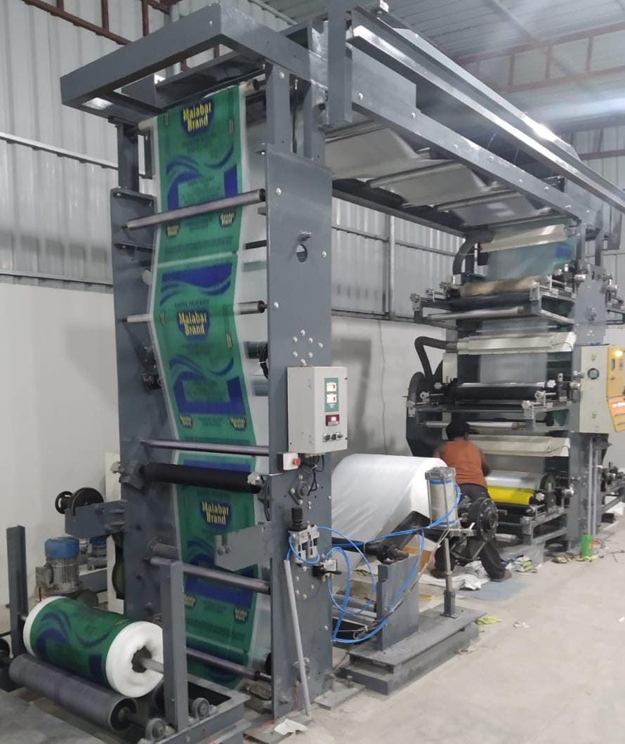

For BIGSO ENGINEERING

Proprietor